PYTHON ASSESSMENT-2

Q2) Execute with one example Lambda Functions in Python &

Read JSON Strings to Python dicts or lists

**Lambda Functions in Python :**

We use the ‘lambda’ Keyword which is often used for short period of time.

Syntax:

Lambda arguments: expression

Lets Consider an example for Lambda function given below :

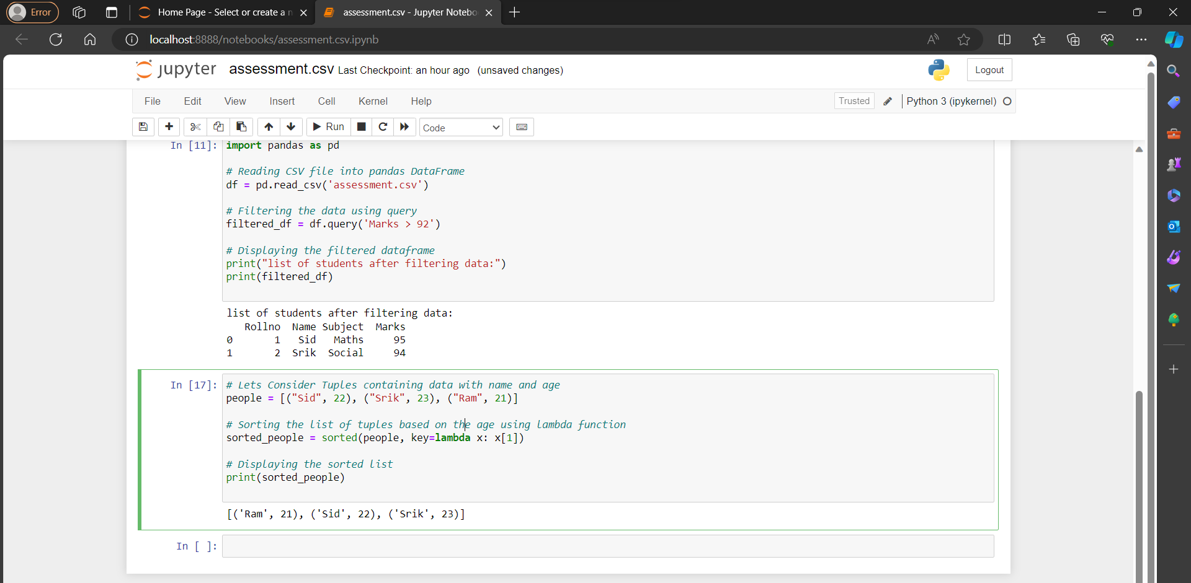

**Read JSON Strings to Python dicts or lists**

In python , we use the module called ‘**json**’ when we work with JSON strings.

The ‘**json.loads()**’ function can be used to parse JSON strings in python dictionaries or lists

